MAKING THE WORLD A BETTER PLACE WITH PRECISE TEMPERATURES
LAUDA presents innovations in temperature control technology for mobile use, laboratories, and pilot plants

Lauda-Königshofen, April 10, 2024 - analytica, the world's leading trade fair for laboratory technology, analysis and biotechnology, has been a fixture for LAUDA DR. R. WOBSER GMBH & CO. KG. This year, the world market leader for temperature control devices and systems will be presenting its product portfolio in six thematic application areas and demonstrating technologies for the present - equipped for the future.

Sample safety and exact temperatures down to -86 °C - also in cold chain logistics
In the field of (ultra) deep-freezing, LAUDA is presenting two solutions, one for storing and one for transporting sensitive samples. With the tried-and-tested Versafreeze range of devices, LAUDA provides freezers and chest freezers of various sizes that enable safe and validated storage at temperatures down to -86 °C. High-quality components and finely tuned technology ensure excellent temperature homogeneity and consistency, outstanding insulation properties, and constant sample safety.

With Mobifreeze, LAUDA presents the world's first mobile, battery-operated ultra-low temperature chest freezer. The actively cooled freezer has a powerful lithium iron phosphate ion battery that enables operation for up to four hours at -80 °C and up to 7 hours at -50 °C, independent of the mains. Delicate and temperature-sensitive substances can be transported safely and under validated conditions between -86 and -50 °C. The Mobifreeze is the reliable solution for intra- and road logistics without the need for dry ice or phase change materials and therefore without the usual challenges of safety and complex logistics planning. By simply switching between mains and battery operation, it can also be used as a hybrid solution, eliminating the need for risky relocations. LAUDA Mobifreeze revolutionizes cold chain logistics and makes frozen sample transport simple and safe.

Modular, sustainable, digital, and powerful: the universal bath thermostats
At analytica 2024, LAUDA is presenting an innovative, comprehensively digitalized, and reinvented portfolio of bath and circulation thermostats for the first time. The new LAUDA Universa device line includes three primary performance classes: Universa ECO, Universa PRO, and Universa MAX, which meet all requirements from low-cost entry-level devices to high-performance professional thermostats. The new range of appliances has a fully modular design; the control heads and baths can be flexibly combined. With bath volumes from 4 to 42 L and bath depths from 160 to 320 mm as well as cooling capacities of up to 1.5 kW and heating capacities of up to 3.6 kW, the ideal technical solution can be configured for every application and an optimum price-performance ratio ensured.
Sustainability was a premise in the design of the new appliance line. This is reflected in the high energy efficiency thanks to the speed-controlled compressor and modern refrigeration control, as well as in the natural refrigerants used across all appliance variants.

As with the LAUDA Integral and Variocool process thermostats, the Universa units will be fully digital. They have an integrated web server for monitoring and control via PC or mobile device, feature a wide range of factory interfaces and a modular interface concept for extended connectivity requirements, and can be used with digital LAUDA solutions such as LAUDA.LIVE and the LAUDA Command app. At the Universa highlight podium, analytica visitors can also gain insight into cloud-based monitoring and remote maintenance with LAUDA.LIVE, which offers numerous analysis and control functions. The LAUDA Command app can also be tried out in detail on other exhibits.

From sample preparation to consumer temperature control - LAUDA solutions for research and development
Reliable and precise temperature control solutions have been LAUDA's core competence for almost 70 years. In the area of research and development, a cross-section of the extensive portfolio will therefore be presented on two podiums at the trade fair. In the temperature control application area, cooling, heating, and calibration thermostats from the Alpha, ECO, and PRO lines will be on display, as well as the Microcool circulation chiller and the LOOP circulation thermostat with Peltier technology. Temperature ranges from -100 to 250 °C are covered here.

Water baths and shakers from the proven Hydro and Varioshake lines will be on display, especially for sample preparation. The Hydro H 20 SW shaking water bath, which is characterized by a load-independent, infinitely adjustable shaking movement with gentle start-up and a cooling coil installed as standard, will be shown as a representative of the wide range of water baths. Two variants of the Varioshake will be exhibited, underlining the versatility and variability of the line. Whether linear, orbital, or overhead shaking, the equipment line offers the right shaking motion for the application. This year, LAUDA will also be exhibiting the Proline PVL 15 see-through thermostat, a device that can be extended with measuring stands and cleaning units from LAUDA Scientific for precise viscosity measurement.

Scale-up and production scales - LAUDA process thermostats
LAUDA also offers the right solutions for production scales and high-performance classes. The Variocool and Integral line of process thermostats will be presented at analytica. The former are the tried and tested solutions for a moderate temperature range. Available in both air-cooled and water-cooled versions, they cover a temperature range from -20 to 80 °C and a cooling capacity of up to 10 kW. The expansion with different pumps and interface modules enables optimum adaptation to variable requirements in the process environment. They are suitable for the temperature control of single-use reactors or for the temperature control of buffer and nutrient solutions.
Process circulators from the Integral range cover a wide temperature range from -90 to 320 °C and are extremely powerful with a cooling capacity of up to 28 kW and a heating capacity of up to 24 kW. They are used in particular in laboratories and pilot plants for reaction control of chemical reactions and syntheses as well as for controlling scale-up processes. They are also highly future-proof with an intelligent interface concept and LAUDA.LIVE connectivity. An Integral IN750 XT will be exhibited, which is ideal for dynamic temperature control tasks and can be used for both pressure-sensitive consumers and applications with high hydraulic resistance thanks to its electronically controlled, magnetically coupled pump.

Remote monitoring and analysis - LAUDA Command (Professional) app
At the Integral and Variocool highlight podium, analytica visitors can get an insight into the LAUDA Command app (free of charge) and the extension to the LAUDA Command Professional app. The app offers numerous control, configuration, and analysis functions and can be used across all device lines. It can currently be used with Integral, Variocool, and Universa appliances, with other lines to follow. The LAUDA Command (Professional) app can be combined with any common operating system and can be used on both desktop and mobile devices, making working with temperature control units more flexible than ever.

LAUDA will be presenting its proven solutions and innovative highlights in Hall B1, Stand 504.
Image 1: LAUDA_Mobifreeze.jpg
LAUDA Mobifreeze is the world's first mobile ultra-low temperature chest freezer. The active cooling enables safe and validated sample transportation. © lauda.de

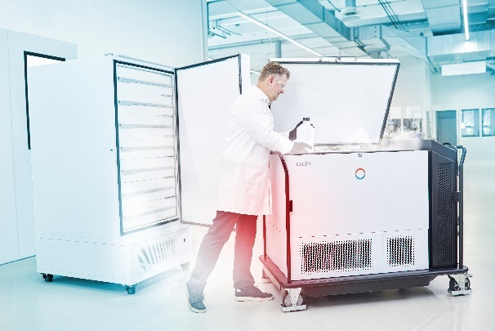

Image 2: LAUDA_Universa.jpg
LAUDA Universa combines the entire portfolio of LAUDA bath and circulation thermostats in one device line - modular, sustainable, digital, and powerful. © lauda.de

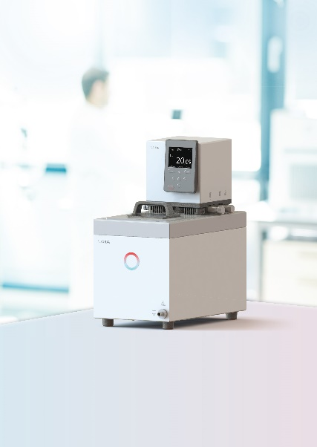

Image 3: LAUDA_Digital.jpg
Driving digitalization forward - remote monitoring, analysis, and control with the digital solutions LAUDA.LIVE and LAUDA Command App © lauda.de

We are LAUDA – the world leader in precise temperature control. Our constant temperature equipment and systems are at the heart of important applications, contributing to a better future. As a complete one-stop supplier, we guarantee the optimum temperature in research, production and quality control. We are the reliable partner for electromobility, hydrogen, chemicals, pharmaceuticals/biotech, semiconductors and medical technology. We have been inspiring our customers for almost 70 years with our expert mentoring and innovative solutions – every day anew and all over the world.

In our company, we always go one step further. We support our employees’ development and are constantly developing ourselves: to create a better future together.

Press contact
We would be happy to provide you with further information and images of our (digital) products or discuss possible trade articles and cross-media presentations of our solutions with you.

Contact us – we look forward to talking to you!

AYLA WOLF CHRISTOPH MUHR
Product Marketing Head of Corporate Communications
T + 49 (0) 9343 503-398 T + 49 (0) 9343 503-349
ayla.wolf@lauda.de christoph.muhr@lauda.de

LAUDA DR. R. WOBSER GMBH & CO. KG, Laudaplatz 1, 97922 Lauda-Königshofen, Deutschland/Germany. Limited partnership: Headquarters Lauda-Königshofen, Registration court Mannheim HRA 560069. General partner: LAUDA DR. R. WOBSER Verwaltungs-GmbH, Headquarters Lauda-Königshofen, Registration court Mannheim HRB 560226. Managing Directors: Dr. Gunther Wobser (President & CEO), Dr. Mario Englert (CFO), Dr. Ralf Hermann (CSO), Dr. Marc Stricker (COO)

